MUHAMMAD MUDASSAR ANWAR

LAB MANUAL 6

CMS#456925

CS-114

28 OCT 2023

LAB TASK 1:

#include<iostream>

using namespace std;

int main()

{

int w,x(0),y(1),z;

cout<<"Enter the number of terms=";

cin>>w;

for(int i=0;i<w;++i) {

cout<<x<<" ";

z=x+y;

x=y;

y=z;

}

return 0;

}

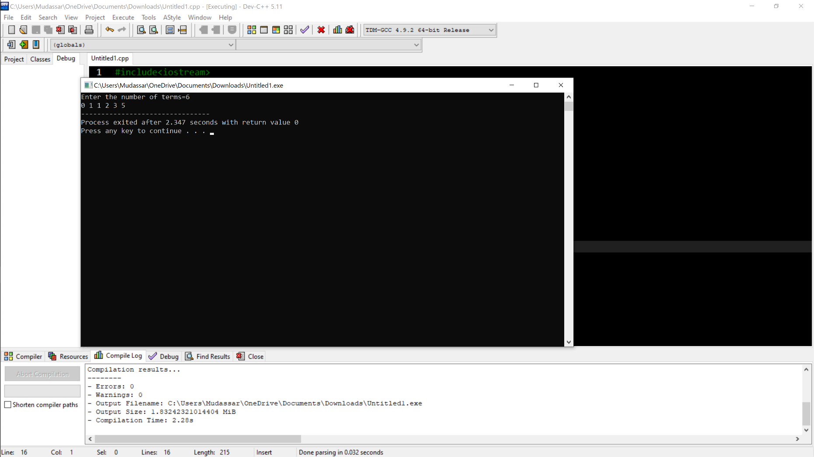

LAB TASK 2:

#include<iostream>

using namespace std;

int main(){

int a,b(1);

cout<<"enter number of rows ";

cin>>a;

for(int i=0;i<=a;++i){

for(int j=1;j<=i;++j) {

cout<<b<<" ";

b++;

}

cout<<endl;

}

return 0;

}

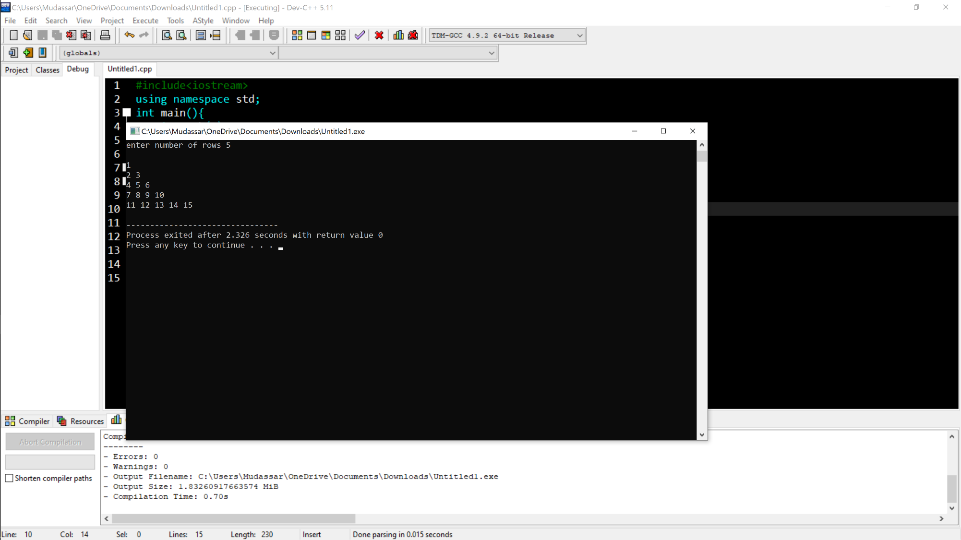

HOME TASK 1:

#include<iostream>

#include<cmath>

using namespace std;

int main() {

int a,x(0);

bool y;

for(int i=2;i<=50;++i) {

y=true;

for(int a=2;a<=sqrt(i);++a){

if(i%a==0){

y=false;

break;

}

}

if(y){

x+=i;

}

}

cout<<"sum of prime numbers is= "<<x;

return 0;

}

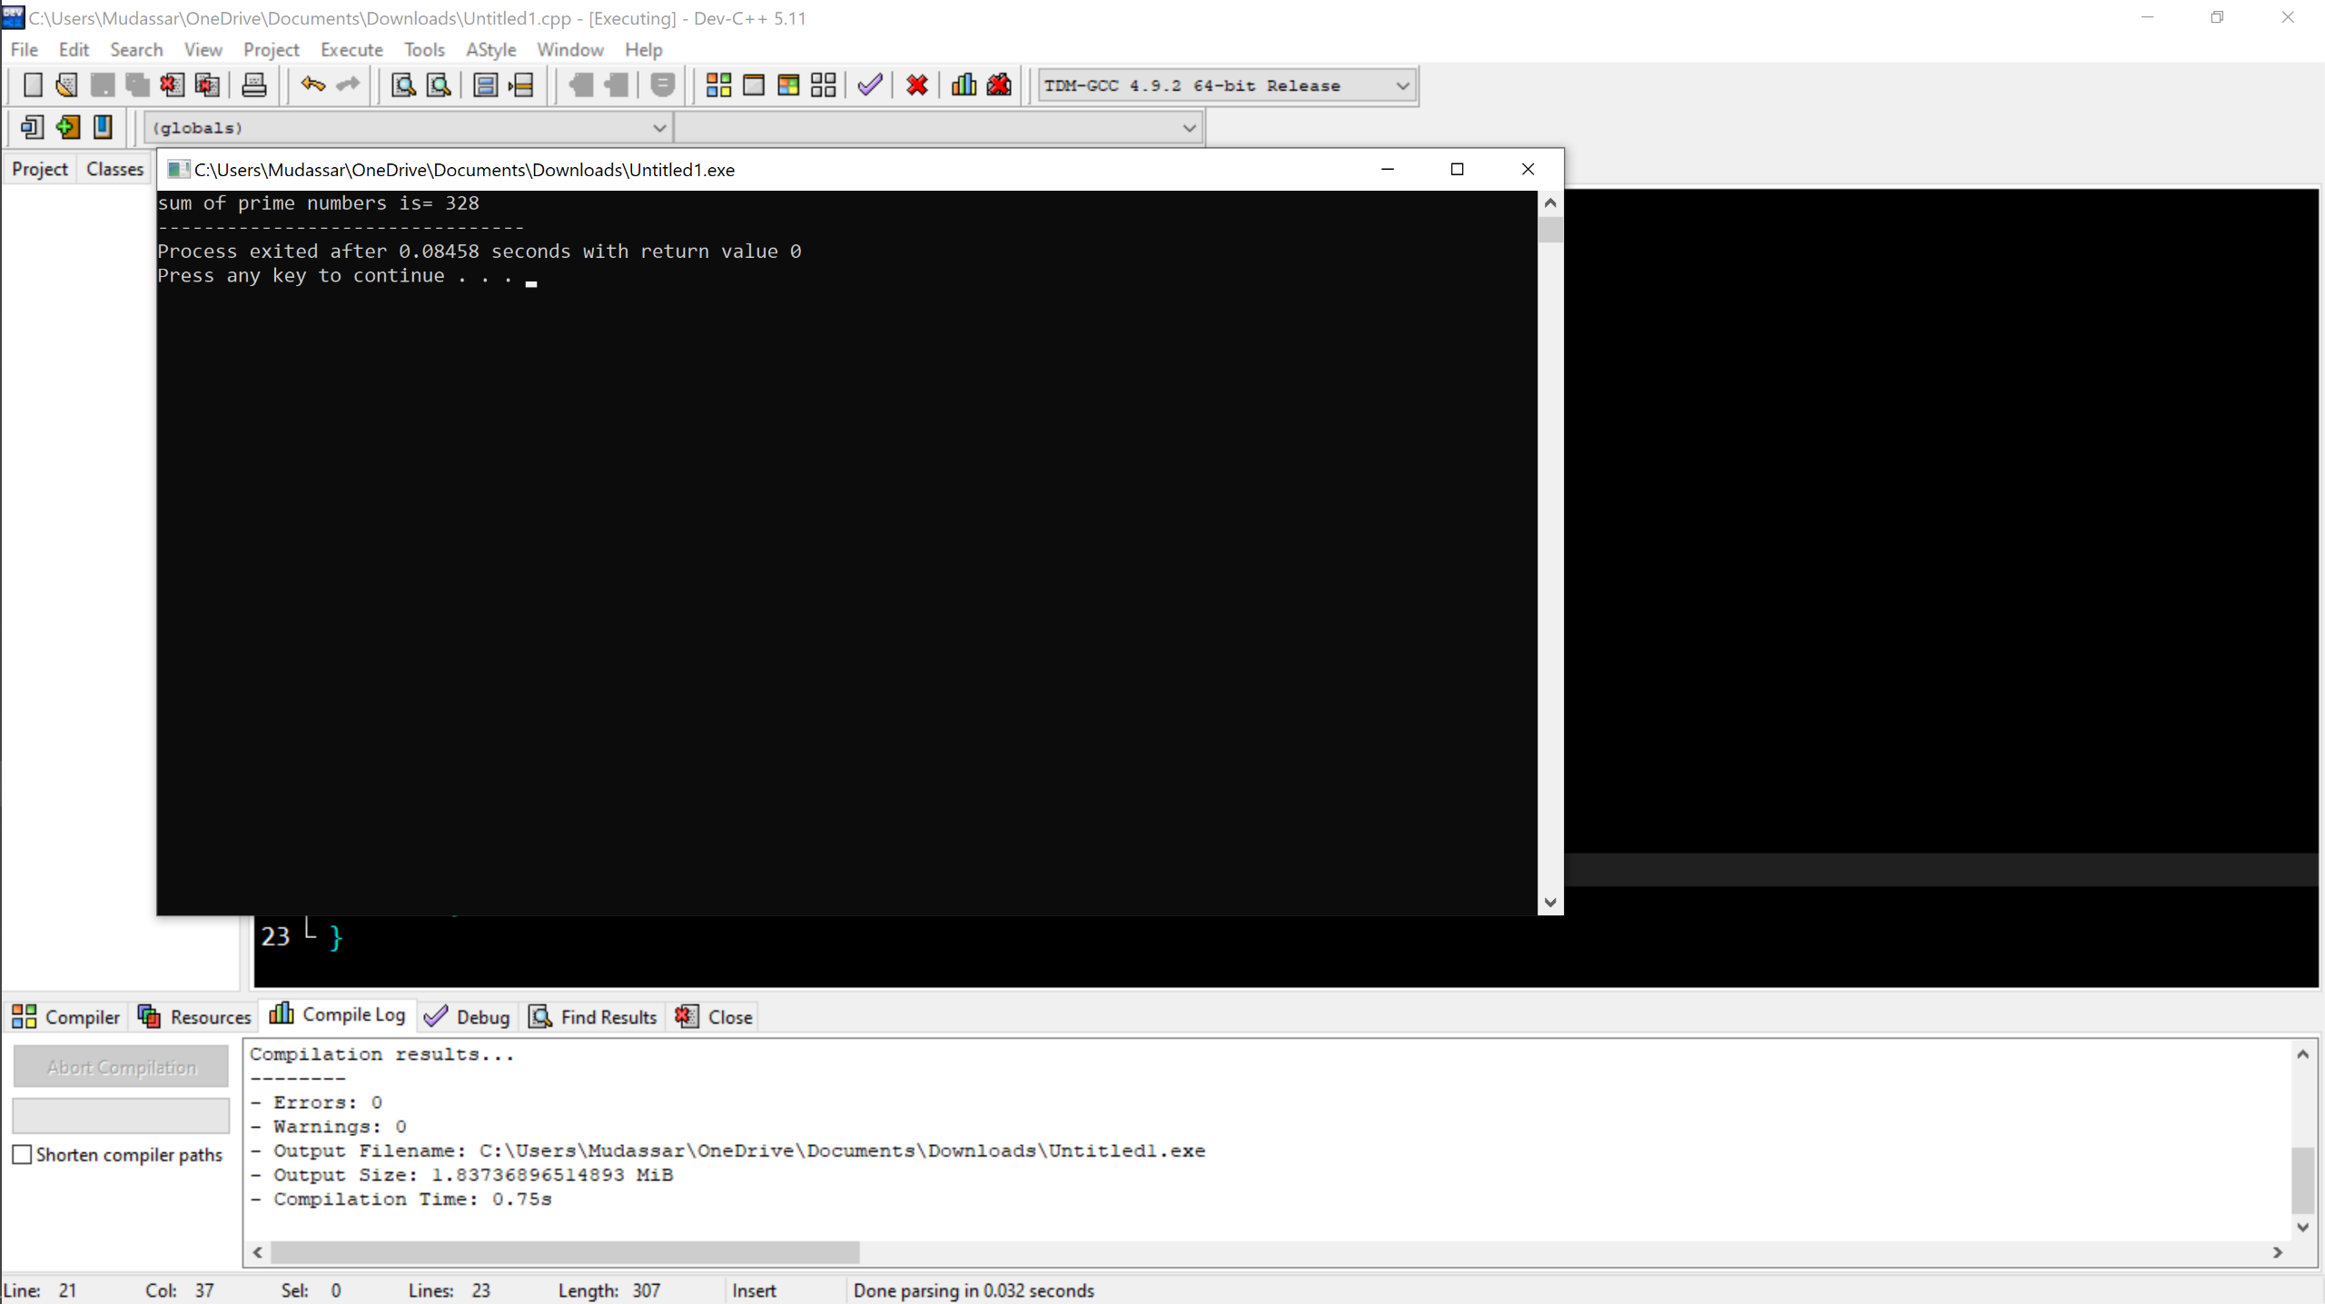

HOME TASK 2:

#include<iostream>

using namespace std;

int main() {

cout<<"pattren is= "<<endl;

for(int i=0;i<=5;i++){

for(int j=1;j<=i;j++) {

cout<<j<<" ";

}

cout<<endl;

}

return 0;

}

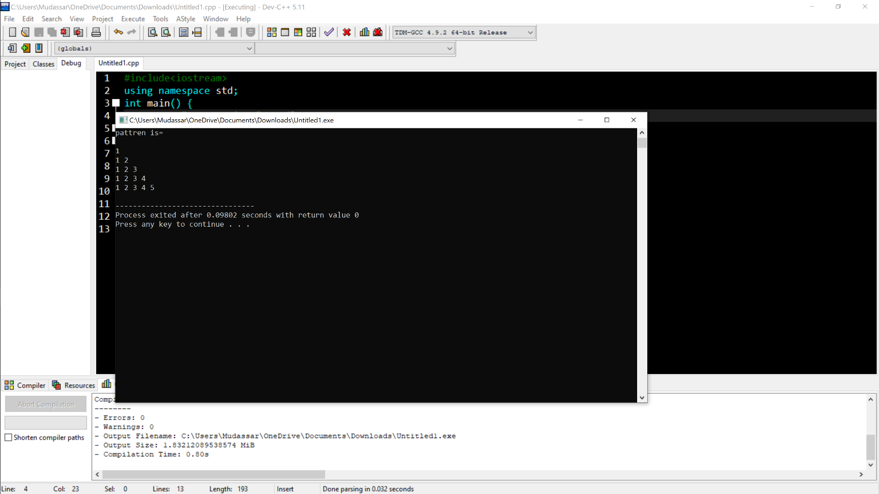

HOME TASK 3:

#include<iostream>

using namespace std;

int main()

{

int a=1;

for(int i=0;i<4;i++){

if(i>=1 && i<=2)

{ a\*=2;

}

else if(i==3)

{a=a+2;

}

else

{

}

for(int j=0;j<a;j++)

{

cout<<a<<" ";

}

cout<<endl;

}

}

